CS2023 - Data Structures and Algorithms

In-class Lab Exercise - Week 5

March 16, 2023

Name: A. C. Pasqual

Index No. : 200445V

**Question 1**

**Terminal Outputs**

1. **Recursive Quick Sort**

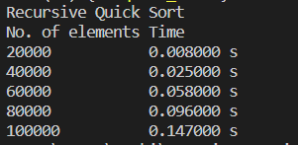

1. **Iterative Quick Sort**

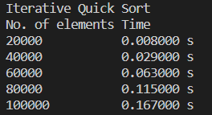

|  |  |  |
| --- | --- | --- |
| **Array Size** | **Time taken for quick sort (ms)** | |
| **Recursive** | **Iterative** |
| 20000 | 8 | 8 |
| 40000 | 25 | 29 |
| 60000 | 58 | 63 |
| 80000 | 96 | 115 |
| 100000 | 147 | 167 |

**Time Graph**

The recursive and iterative algorithms have taken almost the same amount of time, but the recursive algorithm is slightly faster for higher array sizes.

**Question 2**

